Le fonctionnement du Web:

**Distinguish the three parts of the following URL:**

[**http://eduscol.education.fr//actualites/article/sciences-numerique-technologie.html**](http://eduscol.education.fr//actualites/article/sciences-numerique-technologie.html)

**In this query above, where is the page visitor coming from?**

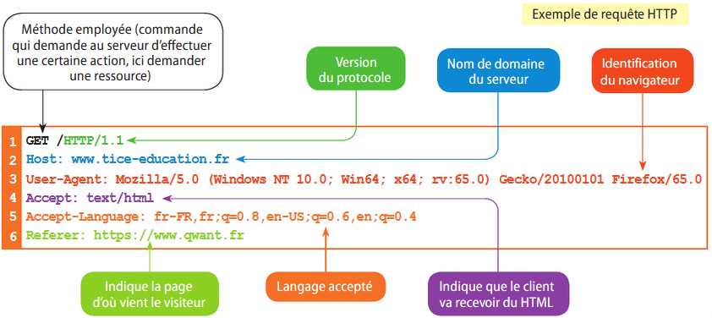

**What part of the server response is displayed on the browser screen?**

**How can we simply describe how the Web works?**

L’écriture d’une page Web :

**Le langage HTML**

**Write the content of the HTML page as it would be displayed on a browser.**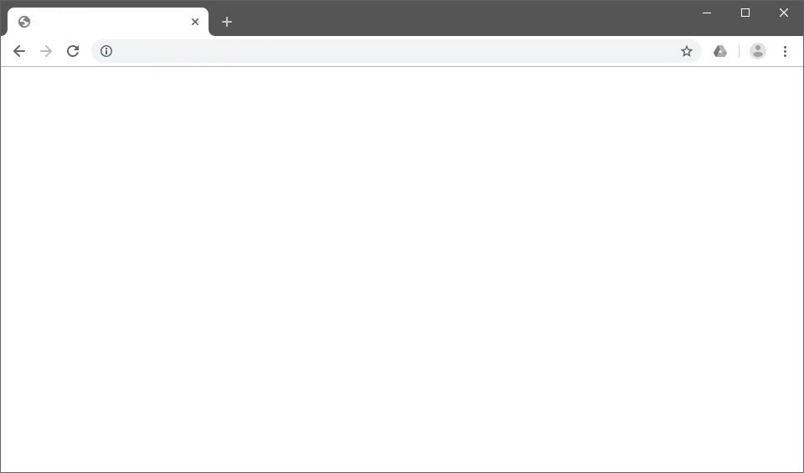

**Complete the HTML page by adding the title “La Classe de Première” at the same level as “Les Classes de Seconde”.**

**Le langage CSS**

**What is the name and font size for level 1 headings?**

**VOUS DEVEZ ALLEZ SUR LE SITE 2SNT POUR REPONDRE CES QUESTIONS :**

**Le couple HTML-CSS**

**What difference do you see between the two versions of the website and where does it come from?**

**What change would have had to be made to display the title The Web in size 54?**

**Les liens hypertextes**

**Which page does the “Contact Us” hyperlink point to?**

**Conclusion**

**How are web pages written?**

Le fonctionnement d’un moteur de recherche :

**MOTEUR DE RECHERCHE**

**Explain the main steps in the operation of a search engine.**

**How do search engines earn commercial revenue?**

**How do search engines influence website publishers' content choices?**

**Based on what you just discovered, are search engine results always neutral?**

Sécurité et vie privée sur le Web :

**SECURITE ET VIE PRIVEE SUR LE WEB DE RECHERCHE**

**How to properly configure a browser to guarantee Internet user confidentiality?**

**How can you ensure that no one learns your browsing history?**



**Is the site pictured above secure? How can we be sure?**

**To create a personal blog, can I copy and paste information from other sites? If yes, under what conditions?**

**What are the main risks on the Web and how can we protect ourselves from them?**